Call Today To Schedule An Appointment
(216) 220-5775
Serving Auto Injury Patients in the Euclid, Richmond Heights, and Cleveland Areas
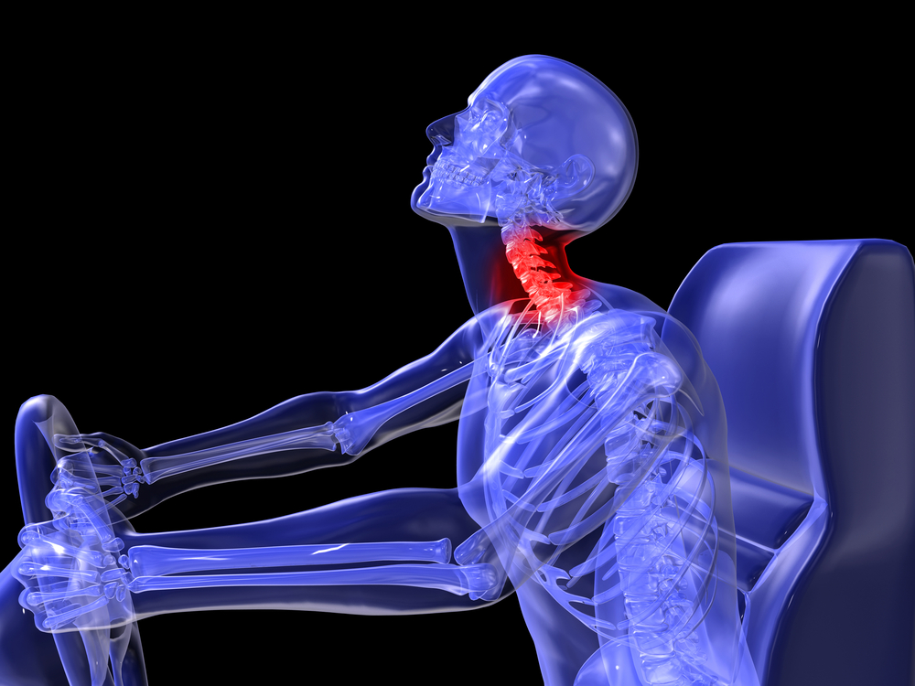
If you have recently been in an automobile accident in Euclid/Cleveland or the surrounding areas, we would like to offer our services in evaluation and possible treatment of any injuries that you may have incurred due to this unfortunate incident.
People often need attention beyond the emergency room care, but fail to seek treatment because many times symptoms subside after a few days. Many times symptoms do not present themselves immediately following an accident, but may surface weeks, months, or even years later.
The above diagram illustrates the potential complications that a low impact collision may cause to the neck. Impact injuries even at low speeds can often cause severe damage to the spine, or damage surrounding muscles and ligaments.
IF YOU ARE EXPERIENCING ANY OF THE SYMPTOMS LISTED BELOW WE WELCOME YOU TO CONTACT US AT (216) 220-5775
- Neck Pain | - Back Pain | - Headaches
- Whiplash | - Muscle Spasms | - Dizziness
- Body Aches | - Pinched Nerves | - Leg Pain/ Numbness
- Arm Pain/ Numbness | - Pain Between the Shoulders

